PROJECT REPORT

ON

**Analysis of software development life cycle with respect to AJIO**

***A comparative study of different models in relation Ajio***

*Submitted to*

**NMAM INSTITUTE OF TECHNOLOGY, NITTE**

(Off-Campus Centre, Nitte Deemed to be University, Nitte - 574 110, Karnataka, India)

In partial fulfilment of the requirements for the award of the

Degree of Bachelor of Technology

In

INFORMATION SCIENCE AND ENGINEERING

By

Abhishek S Shetty NNM23IS004

Under the guidance of

Dr. Jason Elroy Martis, Associate Professor,

Department of Information Science and Technology,

NMAM Institute of Technology. Nitte Karnataka, India



**1.Introduction**

**1.1 What is SDLC:**

SDLC represents the ordered framework to create software through its multiple phases including planning and development and testing and deployment. A suitable SDLC model needs selection to achieve better project success when implementing large-scale systems particularly for Flipkart which operates as a significant e-commerce platform throughout India. The SDLC life cycle aims to create dependable maintainable software systems that fulfill user needs. A software development model needs the SDLC framework in software engineering which creates scheduled plans through which every component can work with efficiency to create software within budgeted deadlines meeting user specifications.

**1.2 Why is SDLC important :**

The task of software development becomes difficult because requirements evolve while both technology and multiple functional groups need to work together. SDLC methodology allows organizations through its systematic management structure to achieve defined deliverables during every phase of their software development process. Such coordination leads stakeholders to both establish mutual agreement about software development needs additionally planning their pathway toward these targets. Some benefits of SDLC:

* Increased visibility of the development process for all stakeholders involved
* Efficient estimation, planning, and scheduling
* Improved risk management and cost estimation
* Systematic software delivery and better customer satisfaction

**1.3 How does SDLC work:**  
It does several tasks required to build a software application. The development process progresses through multiple stages, during which developers implement new features and resolve software bugs.

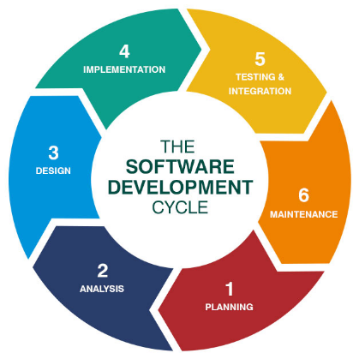

Fig. Software Devlopment Life Cycle

**Stage 1 : Planning & Requirements Analysis**

An inevitable requirement surfaces to obtain the most skilled engineers at software development life cycle's beginning stages. The skillful app development team can establish dependable infrastructure for subsequent software development phases by fulfilling client requirements. The number of essential steps exists in this phase. A preliminary analysis by project team members leads to discovering client aims and issues during this initial stage. After analyzing the results of the evaluation process the team creates different solution options and assigns cost estimates to each one.

**Stage 2 : Defining Requirements**

The sequence of software development life cycle stages continues with a deep dive into the requirements, after the client has  chosen a software solution. The team analyses documents related to the  project, evaluates the client’s existing ecosystem. This is one the software development life cycle steps that some consider transitional, performing it alongside planning and requirements analysis.

**Stage 3 : Designing Product Architecture**

Having fully analysed the client’s requirements on previous software development life cycle stages, the developers create several product architectures and show them to the client.

The chosen architecture is then  finalised in a Design Document Specification (DDS) and evaluated by all  sides in terms of risks, operational reliability, universality, and  cost-effectiveness. This architecture becomes the foundation for all  next stages of software development life cycle and the software product in question.

**Stage 4 : Developing the Product**

One of the most critical software development life cycle phases,  this one aims at producing working code and showing results to the  client. The development takes the majority of time in any project.  Often, the project exceeds the initially estimated time: the client  might consider adding something to the project scope in the course of  the development process. In some SDLC models, the product can change in  the process of the development.

**Stage 5 — Testing the Product**

After all the preparations on previous stages of software development life cycle are completed, quality assurance engineers start scouting for bugs. Testing is another crucial step among the SDLC life cycle phases as it allows for fixing critical problems before they will lead to critical loses.

Even though testing procedures may appear on other software development life cycle stages, as a separate one, testing provides a detailed map of breakdowns that need to be fixed.

**Stage 6 — Deployment & Maintenance**

After the product is release-ready, the next action in the order of software development life cycle steps is to display the finished software solution to the client.

To guarantee the proper work of the finished digital solution in the future, after all the SDLC life cycle phases are  completed, the client can order general product maintenance to fix  different issues This step completes the software development life cycle.

The SDCL model establishes an organized presentation of SDLC concepts for organizations that need to implement it. Different development projects follow various chronological sequences for their SDLC phases to maximize development efficiency. This section presents a review of various popular SDLC models. The Different Models are,

* Waterfall Model.
* Incremental development Model.
* Iterative Model.
* Spiral Model.
* Agile Model.

**2. Introduction to Ajio and Its Business Context**

**2.1 Overview of Ajio**

The online retail company emerged in 2016 under the Reliance Retail subsidiary. The company operates through fashion, accessories and lifestyle product categories to serve their clients. The platform enables customers to shop online while using the omnichannel features which include "Ajio Street" stores. The platform delivers AI recognition capabilities alongside local parcel delivery features with additional AR tools for virtual product exams.

**2.2 Technical and Market Challenges**

* **Scalability:** Handling 10 million+ monthly users during festive sales.
* **Security:** Protecting user data (PCI-DSS compliance for payments).
* **Agility:** Rapid adaptation to fashion trends and regional preferences.
* **Integration:** Syncing with Reliance’s supply chain, Jio platforms, and logistics partners.

**3. Analysis of Waterfall, Incremental and Spiral Model for AJIO**

**3.1 Waterfall Model**

Software development under the Waterfall model follows sequential phases that require designers to finish one phase before starting another. The Waterfall model demonstrates particular benefits and drawbacks in its use for the massive e-commerce platform owned by Reliance Retail which operates under the brand name Ajio. The following sections provide an in-depth analysis of how the Waterfall model would work in Ajio’s operations considering its current challenges and business requirements.

Suitability with respect to AJIO’s context:

The operations at Ajio run stable backend systems and dynamic frontend features which include inventory sync and order processing and AI recommendations with AR try-ons. The Waterfall model works well with Ajio's established fixed-scope projects which have low risk factors but demonstrates weaknesses in implementing agile customer-led solutionsStages of Waterfall Model are:

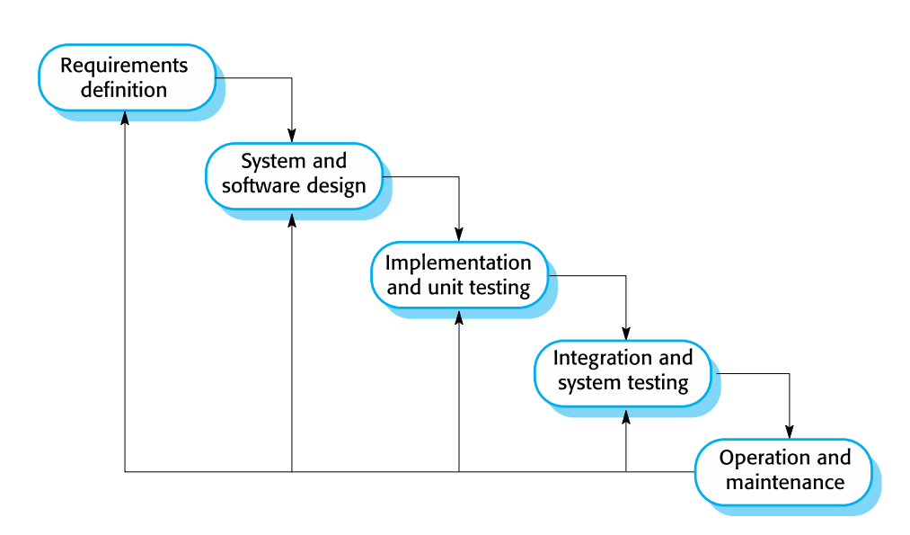

**3.2 Incremental Model**

The Incremental Development Model serves as a Software Development Lifecycle method to construct software through separate incremental builds which deliver parts of the expected product features. System developers perform design then implementation and testing on each increment before its release. The approach adds each block incrementally to reach the complete system. The Incremental Development Model provides an outstanding project solution because it links purposeful planning with ongoing feedback cycles.

Suitability with respect to AJIO’s context:

Providing e-commerce services through Ajio operates within Indian markets which experience dynamic changes between customer demands and technical requirements. The Incremental model fits perfectly for Ajio’s requirements to: Kids Company offers expedited product launches particularly during seasonal fashion cycle changes. The company should adjust its offerings to match different regional customers' preferences through providing ethnic festival-specific clothing.

Incremental Model:

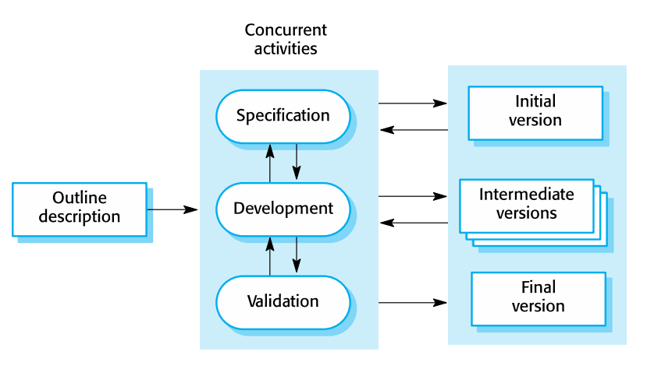

**3.3 Spiral Model**

The Spiral Model presents an iterative SDLC framework as a risk-driven method that incorporates key features of Waterfall and prototyping together with Agile methodology. This model serves Ajio perfectly well which operates under Reliance Retail as an e-commerce platform since it excels at risky innovation-focused projects with complex uncertainties. This document analyzes the Spiral Model structure for Ajio’s business including operational implementation and strategic objectives and organizational challenges.

Suitability:  
Ajio faces intense competition in e-commerce because it needs both quick innovation through tools like AR try-ons and hyperlocal delivery as well as careful risk management of cybersecurity and scalability issues. The Spiral Model provides suitable alignment with Ajio’s business requirements for: Ajio implements high-priority initiatives such as constructing infrastructure to handle sales of 10 million users during holidays. The company uses AI-driven recommendations and blockchain for supply chain transparency in new technological innovation. The company must strike the right balance between operational expedience andystem reliability by synchronizing Jio platforms integration with a 99.9% performance standard of uptime.

Spiral Model:

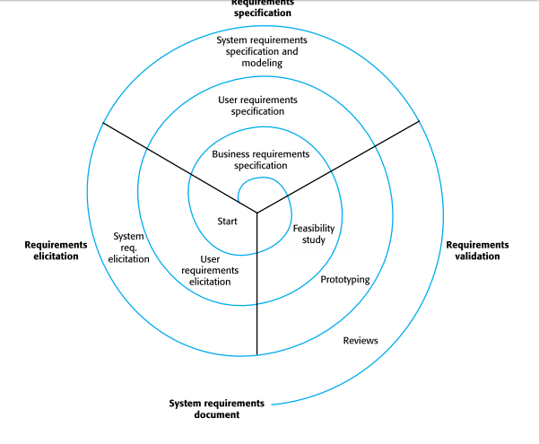

**3.4 Comparison of the models:**

|  |  |  |  |
| --- | --- | --- | --- |
| Aspect | Waterfall | Incremental | Spiral |
| Requirements | Fixed, stable (e.g., compliance modules). | Modular, evolving (e.g., UI/UX updates). | Risk-driven (e.g., cybersecurity upgrades). |
| Risk Management | Reactive (testing at the end). | Moderate (per-increment testing). | Proactive (iterative prototyping). |
| Cost Efficiency | High for fixed-scope projects. | Moderate (phased funding). | High long-term ROI for risk mitigation. |
| Ajio’s aspect | Backend systems, compliance. | Feature rollouts (e.g., hyperlocal delivery). | High-risk R&D (e.g., AI/ML projects). |

**3.5 Preferred Model with respect to Ajio**

It is preferred to use the hybrid model including both spiral and incremental model.

**3.5.1 Strategy:**

High-risk innovations such as blockchain loyalty programs should use Spiral as their development model. Regular Feature Releases utilize the combination of Incremental and Hybrid SDLC design for implementing new features. This method works well with introducing regional language capabilities.

* + 1. **Why incremental development model:**
* **Early Risk Identification**: The approach of developing projects incrementally enables you to manage risks through smaller segments which produces less overall project danger.
* **Faster Feedback Loops**: The product development process shows partial deliverables to stakeholders and end-users thus enabling their continuous feedback to help the final product match their required specifications.
* **Flexibility to Accommodate Changes**:The hybrid approach combines traditional planning systems from the traditional model with agile flexibility because of its adaptability for changes. The incremental delivery system helps organizations smoothly transition new demands and changing project needs.
* **Better Resource Management**: Small divisions within a project enable teams to distribute resources better while tracking progress along with making essential plan modifications.
  + 1. **Why spiral model:**
* **Risk-driven Development:** Risk analysis takes place during each spiral iteration to uncover potential problems which can be properly addressed before receiving larger scope.
* **Adaptability to Changing Requirements**: The periodic review process grants stakeholders a chance to direct requirement modifications which therefore simplifies project adjustments throughout development.
* **Enhanced Stakeholder Involvement**: The stakeholder involvement achieves greater enhancement through empirical reviews performed at spiral phase termination points that enable organization requirement maintenance.
* **Incorporation of Prototyping:** Each development cycle requires prototyping as a fundamental component to permit teams to validate their concepts and make important design decisions right from the start in hybrid work environments.

**4. Functional and Non-functional requirements of AJIO**

**4.1 Functional requirements**

Business operations and system features which a system needs to support to fulfill requirements operate as functional requirements. The functional specifications at AJIO aim to deliver smooth online shopping processes to all system users including vendors and administrators.

* **User Registration & Authentication:** Users can perform authentication through account creation and profile customization steps as well as validate their registration with multiple access methods. Features like password recovery and social media login integration.
* **Profile Management:** Modify personal information such as name and address together with contact data. Users can control their stored payment options as well as account preferences within their profile.
* **Search & Filters:** Keyword-based search with auto-suggestions. Users can order products on the website by sorting through product categories (ethnic wear and accessories) as well as price parameters (ranges and sizes) and brand lists and customer evaluation ratings.
* **Product Catalog:** Detailed product pages with images, videos, descriptions, and customer reviews. Customers need to see supply status along with delivery timing information for all products.
* **Cart Management:** Users can add or remove items from their cart while adjusting quantity amounts before saving them for future use. Customers can benefit by using promotional codes together with coupons and vouchers available at JioMart.
* **Returns & Refunds**: The customer can start a return or exchange process within the designated timeframe. The system automatically processes refunds through the same payment methods that customers originally used.
* **Secure Transactions:** PCI-DSS compliance for payment processing. End-to-end sensitive data encryption occurs when the system protects all details from beginning to termination.
* **Mobile & Cross-Platform Compatibility:** The responsive design system enables ease of operation between web applications and mobile applications thanks to its support for mobile and cross-platform compatibility. Consistent user experience regardless of the platform.

**4.2 Non-functional requirements**

System qualities which guarantee efficiency together with security and usability are defined by non-functional requirements. The company’s performance together with its reliability and scalability depends directly on these important system attributes.

* **Scalability** – The system must demonstrate ability to process millions of users together with concurrent transaction volume and extensive traffic demands throughout festive season discount periods.
* **Security** – In order to protect data companies should implement encryption and multi-factor authentication together with fraud detection systems to prevent breaches from unauthorized access and data protection.
* **Performance** – To offer a seamless shopping experience users should expect AJIO to maintain fast page loading times together with quick response times and superior search results optimization.
* **Availability** – The platform must operate at 99.99% uptime to maintain continuous operations because any downtime would result in financial losses while dissatisfying customers.
* **Usability** – The platform needs a user interface which provides clear navigation with responsive interactions across desktops and smartphones together with tablets.
* **Compliance** – AJIO needs to follow system regulations for data privacy under GDPR and secure payment processing under PCI DSS to guarantee customer information security.
* **Maintainability** – The system architecture needs to adopt a modular design approach which allows updates, bug fixes and enhancements to proceed without disrupting the complete platform.

**4.3 How SDLC Models Affect Time & Cost for AJIO**

* **Waterfall Model:** Lower initial cost but high rework expenses due to late-stage testing and slow feature releases.
* **Incremental Model:** Moderate cost spread over time; faster releases, making it cost-efficient.
* **Spiral Model:** This model requires high costs to perform extensive risk management activities which helps prevent failings that would create long-term expenses.

**4.4 Conclusion**

The evaluation shows that AJIO should use an integration of the Incremental model with the Spiral model. A continuous update capability and rapid market deployment become possible through the Incremental model due to its characteristics. This proves beneficial for developing evolving e-commerce platforms. Production utilizing the Spiral model enables successful security controls and scalability together with risk management which are essential for executing large financial processes and serving changing customer needs. AJIO will preserve its market agility and security while remaining competitive through implementation of these two development models together.

**5. Requirements Elicitations and Validation**

**5.1 Requirements Elicitations**

* **Stakeholder Interviews:** Contact internal teams which include product managers and marketing and IT personnel to gather business targets and technical boundaries. The project should include interviews with essential outside stakeholders including partners who supply goods as well as logistics companies and final product users.
* **Surveys & Questionnaires:** Online surveys should be administered to existing customers and prospective users to determine their desired features while discovering their current problems. Your survey design should include standardized questionnaires to obtain consistent results while detecting major feedback patterns.
* **Focus Groups:** Target customers from specific groups should attend sessions to share their thoughts about shopping practices and expected features together with their difficulty using products. Utilize qualitative data collection to enhance the design process of new features or improved features.
* **Workshops & Brainstorming Sessions:** The team should organize collective meetings with design as well as development and marketing teams to determine priority needs. You should apply brainstorming along with storyboarding to develop user pathways and system connection sequences.
* **Observation & User Behavior Analysis:** Web and application analytics data enable businesses to track user activities which helps them locate navigation problems along with investigation of areas where users stop interacting with the system. Watching users allows organizations to discover actual usability problems at the same time as future development prospects.
* **Prototyping & Usability Testing:** Early functionality testing requires production of wireframes and prototypes for usability assessments which obtain early design feedback and reduce usability issues. User feedback must guide the development team to revise prototype versions before formal development starts with requirements at their optimal preparedness level.
* **Review of Customer Support Data:** You must study both customer comments and social media interactions and support service logs to detect regular problems and requested functions. The analysis of CRM data reveals typically encountered queries as well as user-specific problems that need resolution.
* **Use Case & Scenario Analysis:** The platform's interaction design requires developing comprehensive use cases together with scenarios which demonstrate the platform usage of various user types. Detect all potential exceptional scenarios and exceptional cases which demand unique treatment in the system architecture.

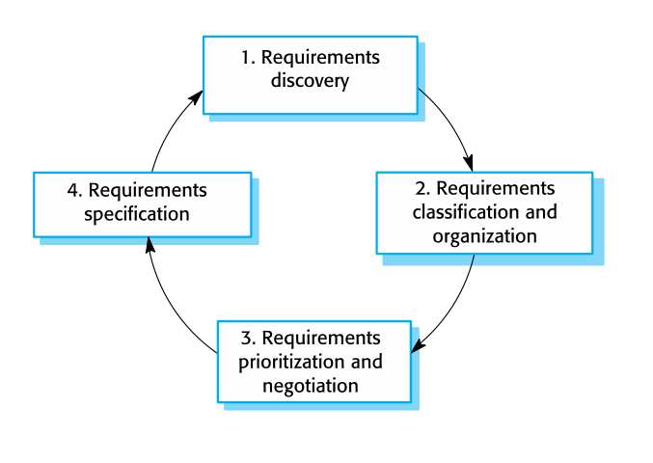

**5.2 Requirements Validation**

Requirement’s validation is nothing but making sure that all the requirements are in agreement with the stakeholder’s requests. In other words, it is about checking if the requirements are complete, consistent, and correct.

**5.2.1 Requirements Validation Strategy**

Requirements validation ensures that AJIO’s system meets business needs before full-scale development. The key strategies include:

* **Stakeholder Review:** Gathering feedback from customers, sellers, and administrators.
* **Prototyping:** Developing early UI mockups and interactive demos for validation.
* **Requirement Traceability Matrix (RTM):** Ensures each requirement is linked to a deliverable.
* **Automated Testing & Verification:** Running test cases to check requirement compliance.
* **User Acceptance Testing (UAT):** Conducting real-world trials with selected users.

**5.2.2 Challenges in Requirements Validation**

* **Changing Business Needs:** E-commerce trends shift rapidly, making static requirements obsolete.
* **Diverse Stakeholder Needs:** Balancing different user expectations can be challenging.
* **Scalability Considerations:** Ensuring new features won’t affect performance at scale.
* **Security & Compliance:** Validating security measures against evolving cyber threats.

By combining **Incremental and Spiral models**, AJIO ensures robust requirement validation while maintaining flexibility to adapt to market needs.

**6. Conclusion**

The analysis of AJIO’s requirements reveals a well-rounded platform that effectively addresses the needs of its diverse user base. Functionally, AJIO incorporates essential features such as comprehensive product catalogs, advanced search and filtering options, secure checkout processes, and dynamic order management. These features ensure that the platform not only meets customer expectations but also provides an engaging, efficient, and user-friendly shopping experience. The detailed functional requirements support seamless interactions, promoting higher customer satisfaction and retention.

Complementing the functional aspects, the non-functional requirements underscore AJIO’s commitment to performance, security, and scalability. The platform is designed to handle high volumes of traffic with fast response times, ensuring reliability even during peak periods like sales or promotions. With robust security measures, strict compliance with industry standards, and a focus on accessibility and maintainability, AJIO is well-prepared to offer a secure and resilient environment for its users. This attention to non-functional aspects ensures that the overall system remains efficient, adaptable, and reliable over time.

Lastly, the requirements elicitation process for AJIO plays a crucial role in aligning technical development with market and customer expectations. By leveraging a mix of stakeholder interviews, focus groups, surveys, market research, and usability testing, the development team is able to capture comprehensive insights into both current and evolving needs. This systematic approach not only facilitates the creation of a feature-rich platform but also ensures that the design remains responsive to the dynamic e-commerce landscape, ultimately positioning AJIO for sustainable growth and long-term success.

**References**

1. Sommerville, I. (2015). *Software Engineering* (10th ed.). Pearson.
2. Pressman, R. S. (2019). *Software Engineering: A Practitioner's Approach* (9th ed.). McGraw-Hill.
3. IEEE Computer Society. (1998). *IEEE Recommended Practice for Software Requirements Specifications* (IEEE Std 830-1998).
4. DataRob (2024). "Understanding SDLC Models and Their Applications." Retrieved from <https://www.datarob.com>
5. GeeksforGeeks (2024). "Software Development Life Cycle (SDLC) - Models, Phases, and Advantages." Retrieved from <https://www.geeksforgeeks.org>
6. ChatGPT (2025). "Software Development Lifecycle Models and Analysis." OpenAI.
7. Deepseek(2025). "Software Development Lifecycle Models and Analysis."

**Github repository:**

https://github.com/Abhi-Shetty0/SDLC-Real_World